|  |
| --- |
| **mAK GAMES** |
| BOUNCY |
| **[THE JUMPING BALL]** |
| Version #01  All work Copyright © 2016 by MAK GAMES.  All rights reserved. |
| **[AMIT KUMAR]** |
|  |

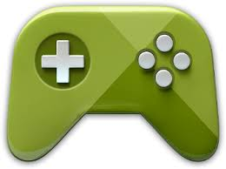

|  |
| --- |
| OCTOBER 21th 2016 |

1. **Game Overview**

*Bouncy is a simple platform game where player can move to left and right of the screen and can jump to avoid the enemies and to reach the platforms to save himself from falling. The player in starting has 5 lives and it reduces as it touches the enemy or fall from the platform. The player must collect the stars to make score.*

1. **Camera**

*The camera for this game uses an orthographic projection.*

1. **Controls**

*The player can use” Upper Arrow Key” to jump , “Left arrow key “to move to left side and “Right arrow key” to move right side.*

1. **Saving and Loading**

*This game does not include any saving and loading options.*

1. **Interface Sketch**

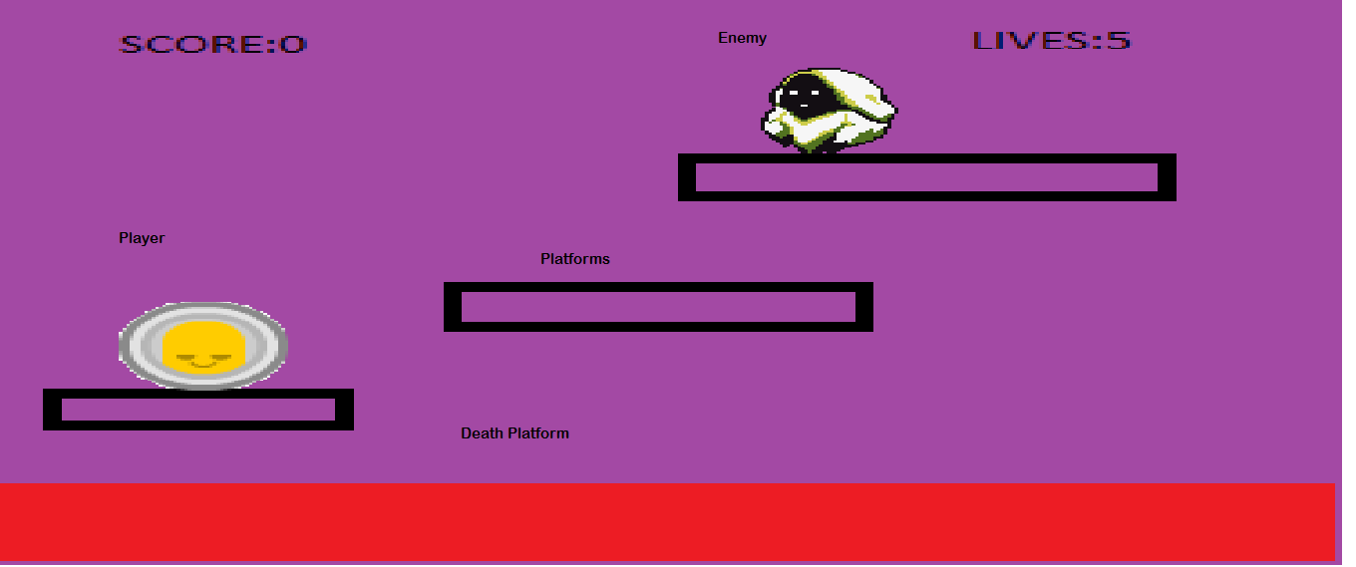

1. **Game Elements**

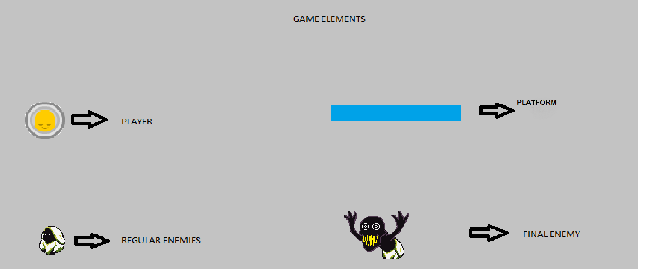

1. **Menu and Screen Descriptions**

***Start:***

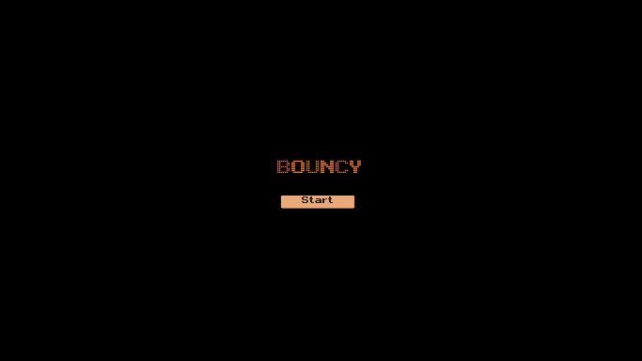

***Start:***

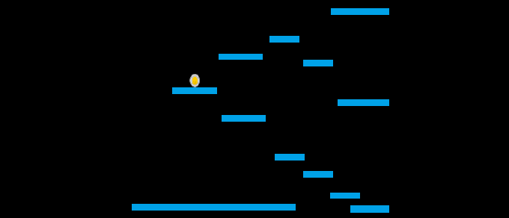

***PlayMode****:*

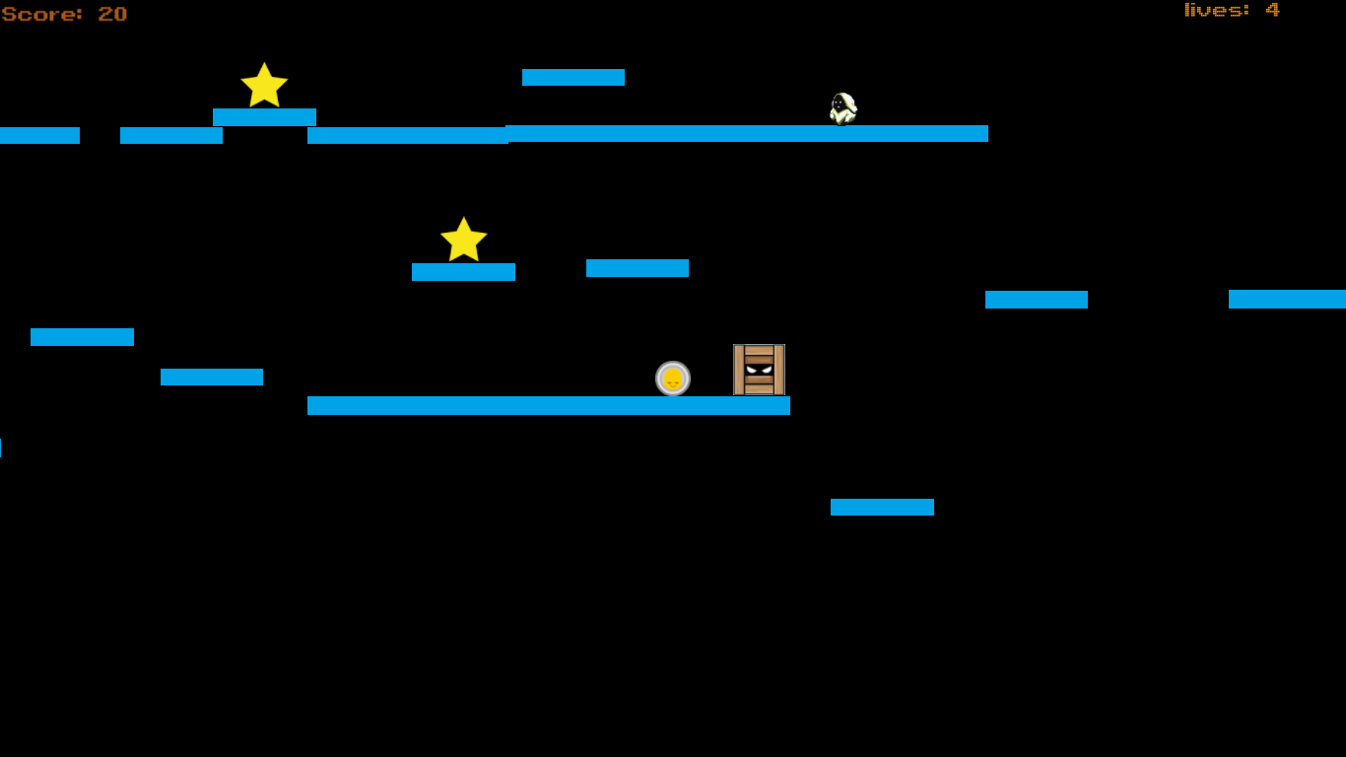

***END:***

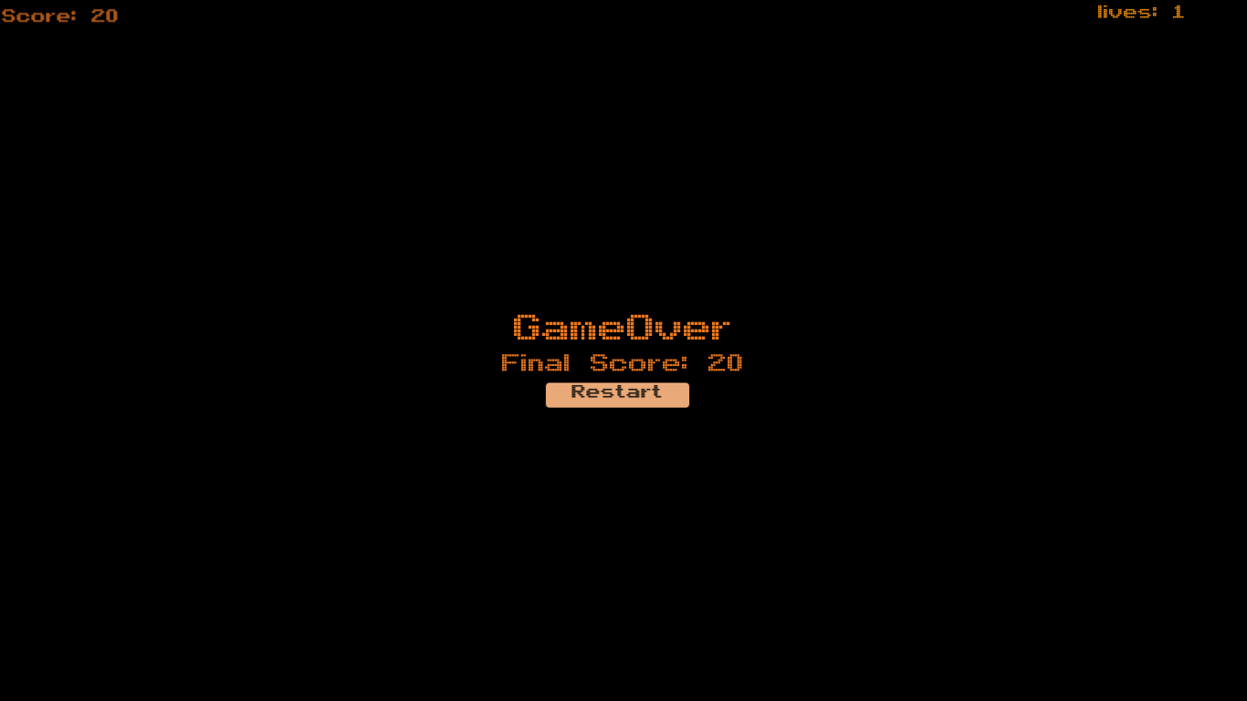

1. **Characters**

*The player’s avatar is a smiley that is moving and jumping from one platform to other avoiding the enemies and collecting the stars.*

1. **Enemies**

*The enemies in the game are still ghosts which player has to avoid otherwise he will die.*

1. **Weapons**

*The player now has no weapons*.

1. **Items**

Boxes are present in the game to help the player to jump higher.

1. **Scoring**

The player’s score increase when he/she collects the stars.

1. **Sound Index**

|  |  |
| --- | --- |
| **NAME** | **AUDIO** |
| **Casual Death.mp3** |  |
| **Hurt Sound.mp3** |  |
| **Jump.mp3** |  |
| **Star.mp3** |  |
| **Gameover.mp3** |  |

1. **Art / Multimedia Index**

|  |  |  |
| --- | --- | --- |
| **NAME** | **IMAGE** | **DETAILS** |
| **PLAYER.png** |  | **PLAYER’S AVATAR** |
| **Ghost1.png** |  | **Ghost1** |
| **Ghost2.png** |  | **GHOST2** |
| **Star.png** |  | **Bonus** |
| **Box.png** |  | **Helping Box** |

1. **Future Features**

*In future, I am willing to add weapons to the game by which player can kill the enemies and the enemies can give some trouble to the player and moreover there will be some trap platforms to increase the difficulty of the game.*

1. **Design Notes**

*Making this game was fun. It was a great experience making this game. I enjoyed it firstly I designed my platforms and find doing the coding a great experience for this game. I faces some difficulties though because I was unable to attend some classes in college but the lectures on YouTube helped me a lot.*